*TECNO mobile*

TECNO SPARK 7

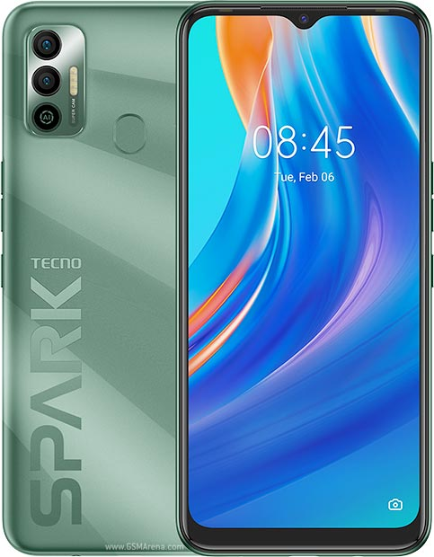

Tecno Spark 7 Android smartphone. Announced Apr 2021. Features **6.5″ display**, MT6762D Helio A25 chipset, 6000 mAh battery, 64 GB storage, 4 GB RAM.

**PRICE /** 19,999 **PRK**